**YMCA Aerobics**

**Effective June 1, 2016**

**Punch Cards – Good for all Classes**

Member Rates:

(12) Class Punch Card $25.00

Non-Member Rates:

(12) Class Punch Card $32.00

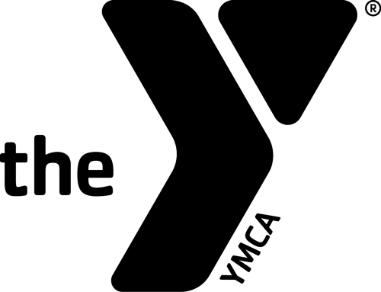

Monday Tuesday Wednesday Thursday Friday Saturday

|  |  |  |  |  |  |
| --- | --- | --- | --- | --- | --- |
| 6:30am - 7:00am  Feeling Fit Class  **Ted** |  | 6:30am - 7:00am  Feeling Fit Class  **Ted** |  | 6:30am - 7:00am  Feeling Fit Class  **Ted** |  |
| 8:30am - 9:15am  Feeling Fit Class  **Ted** |  | 8:30am - 9:15am  Feeling Fit Class  **Ted** |  | 8:30am - 9:15am  Feeling Fit Class  **Ted** |  |
| 9:00am -10:00am  Yoga  **Jimi** |  |  |  |  |  |
| 9:45am – 10:45am  Water Fitness  (free w/membership)  **Jim** |  | 9:45am – 10:45am  Water Fitness  (free w/membership)  **Jim** |  | 9:45am – 10:45am  Water Fitness  (free w/membership)  **Jim** |  |
|  |  | 5:30pm – 6:30pm  Yoga  **Jimi** |  |  |  |
| 6:00pm – 7:00pm  Zumba  **Darlene** | 5:30pm – 6:30pm  Water Fitness  **Wendy** | 6:00pm – 7:00pm  Zumba  **Darlene** | 5:30pm – 6:30pm  Water Fitness  **Sabine** |  |  |

**Feeling Fit:** These classes are designed to work deep and superficial muscles that stabilize, align and move the truck of the body especially the abs and muscles of the back. You’ll

work your entire core and learn new exercises to sculpt the body. It’s a great way to fit a quick yet challenging workout into your day.

**Water Fitness**: Whether you are coming back from an injury or are looking for an environment that surrounds you, literally, with resistance. Make the class as hard or easy as you

need it to be. No swimming skills are necessary and participants can modify all exercises to their level of fitness.

**Yoga**: Coming to a new yoga studio can be intimidating, but our classes welcome everyone, regardless of fitness level or yoga experience. Yoga is not just for young flexy people, but

a regular Yoga practice can help build balance, flexibility and strength. Come and join us for a practice and explore your potential. All poses can be modified for all fitness levels.

Remember, it’s YOUR practice -- your best teacher resides within you.

**Zumba:** Zumba for the active participant. Helps build muscular strength, increase bone density and improve mobility, posture and coordination.